Task on terraform-02
1). Watch the Terraform-02 video.
2). Execute all the templates shown in the video.
Using two providers in a same configuration file
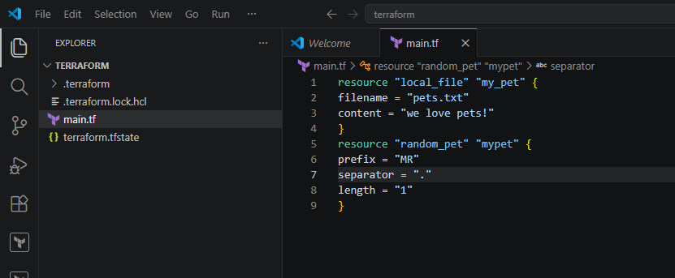
Initializing backend : terraform init
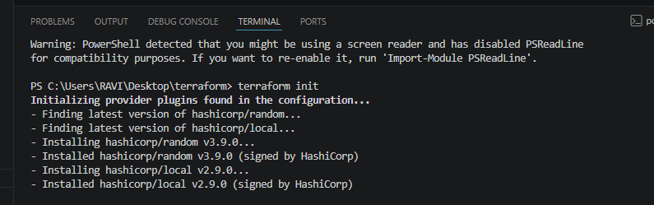
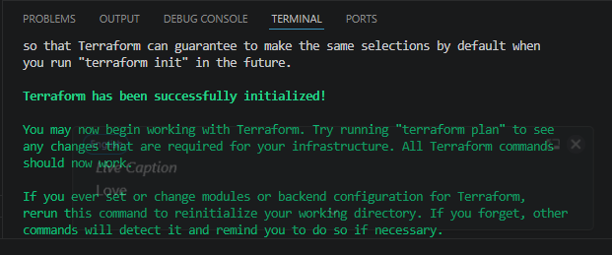
Terraform plan:
we made the changes in the above content and then it was shown below:
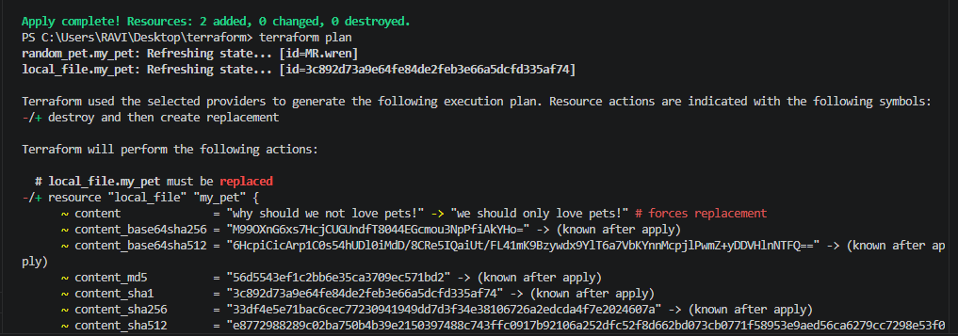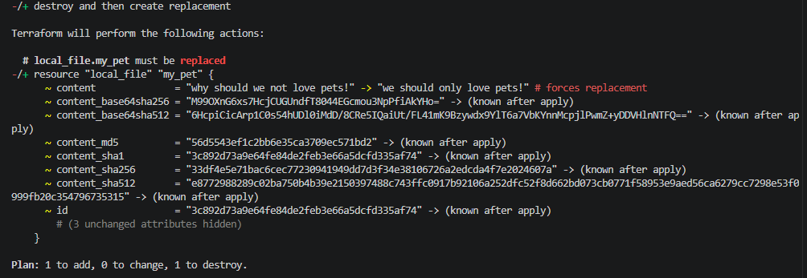
Terraform apply
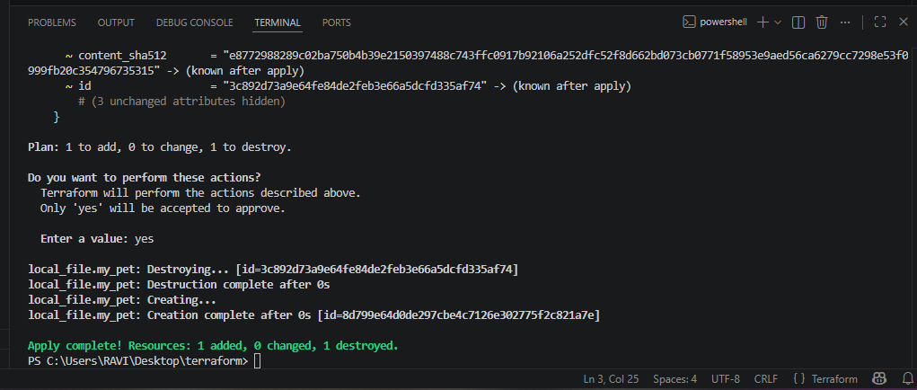
Made changes to the main.tf file.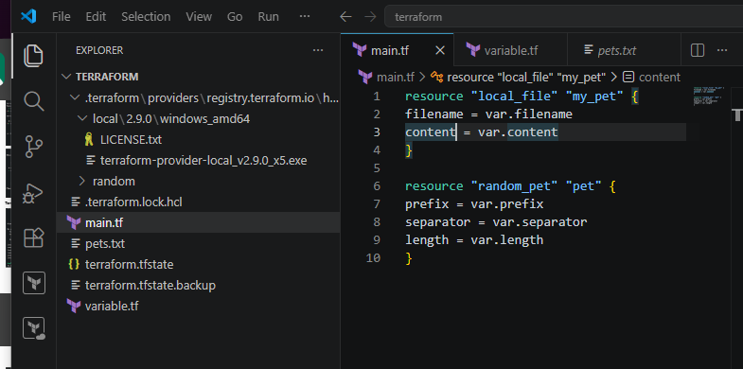
Now lets create variable.tf file and added the below content in the same:
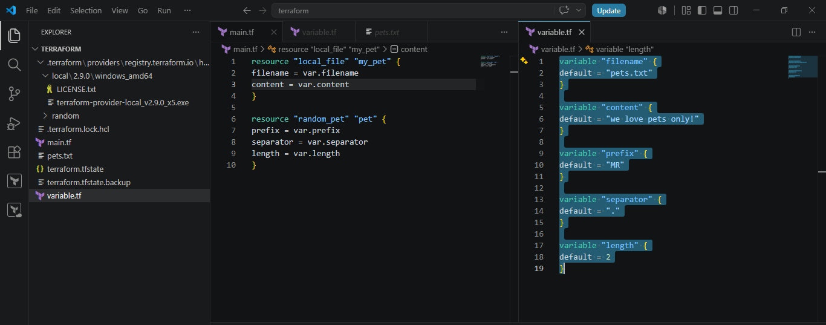
Instead of hard coding the values inside main.tf file we have created a variables.tf. So main.tf will use those variables with var.content, var.filename etc
Now lets perform terraform init
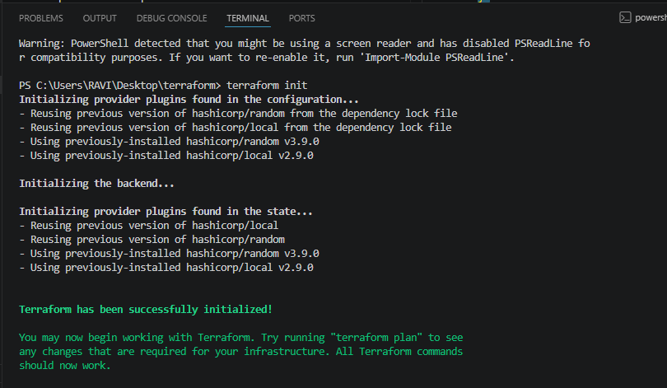
Now terraform plan and you will see the below outputs here and the final output in the pets.txt file.
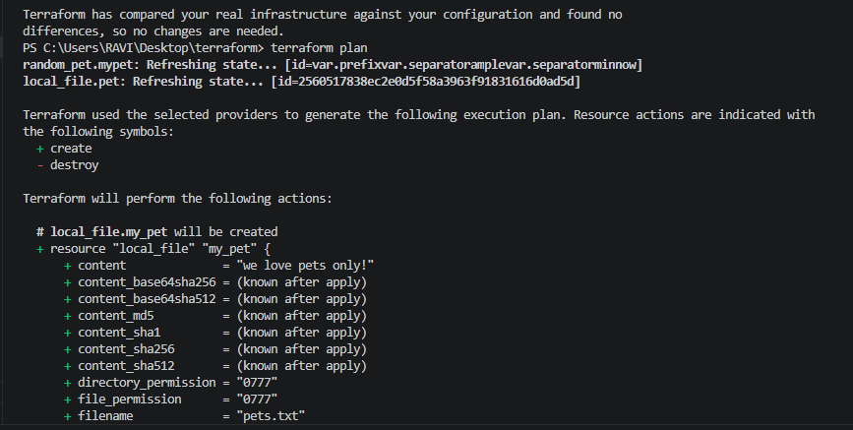
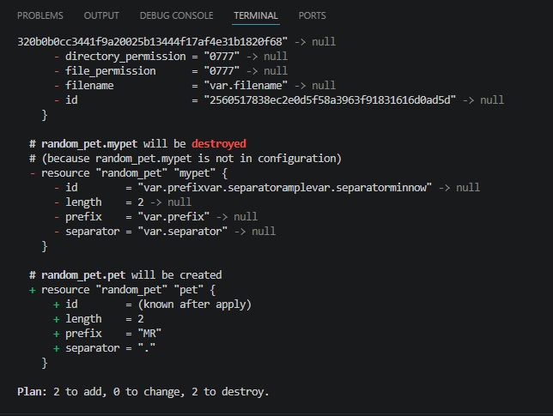
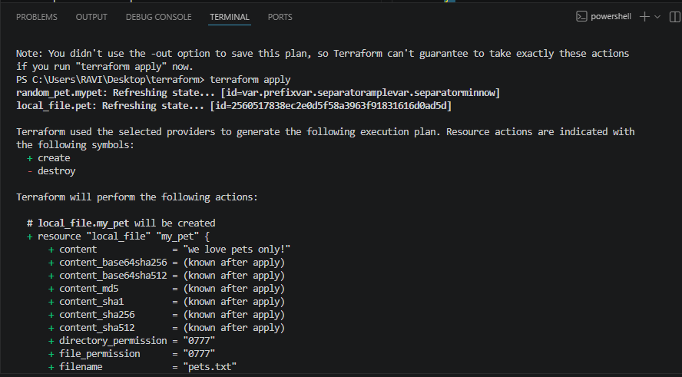
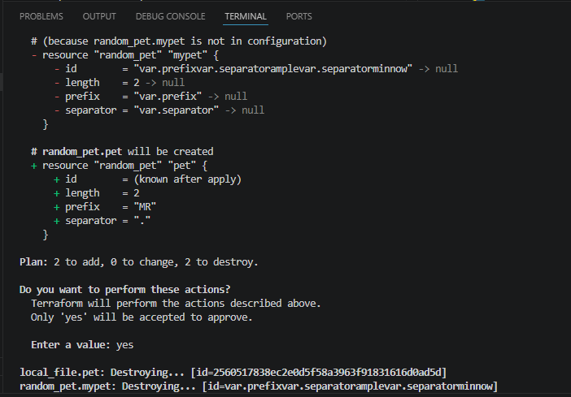
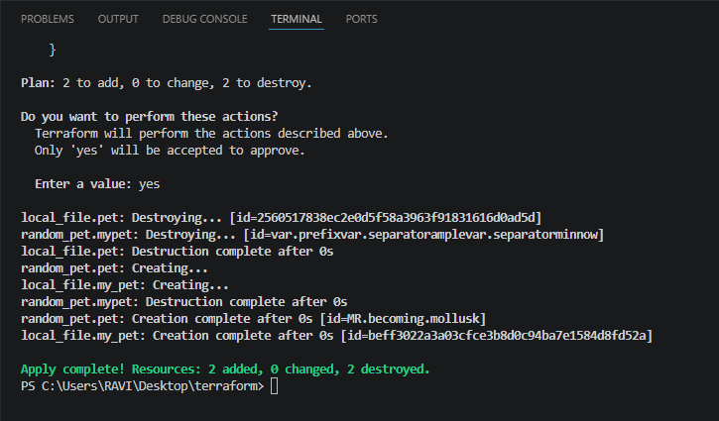
Final output showed in the pets.txt file: 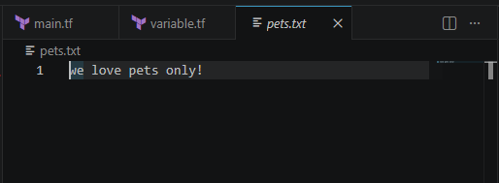
3). Integrate Terraform in Jenkins using the Terraform plugin.
Lets install terraform plugin in Jenkins
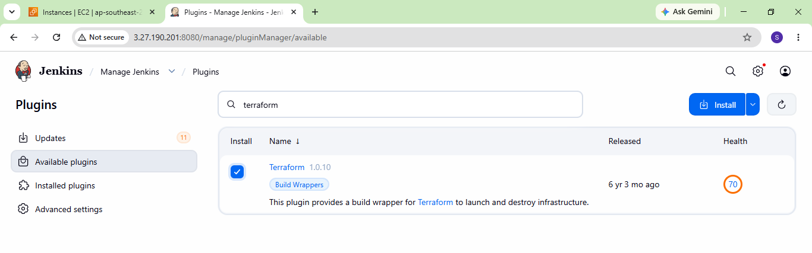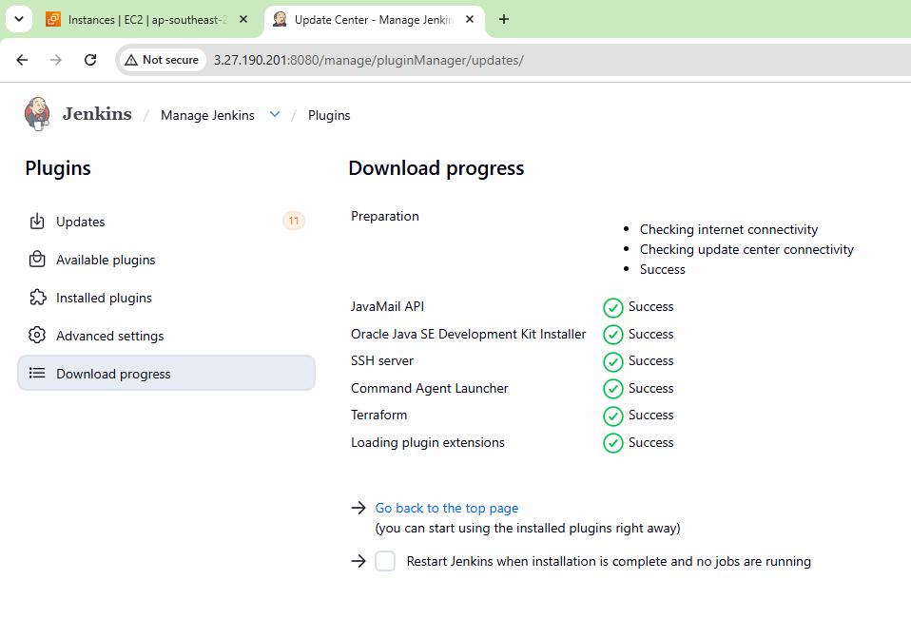
Configure terraform
Tools terraform installation give name save
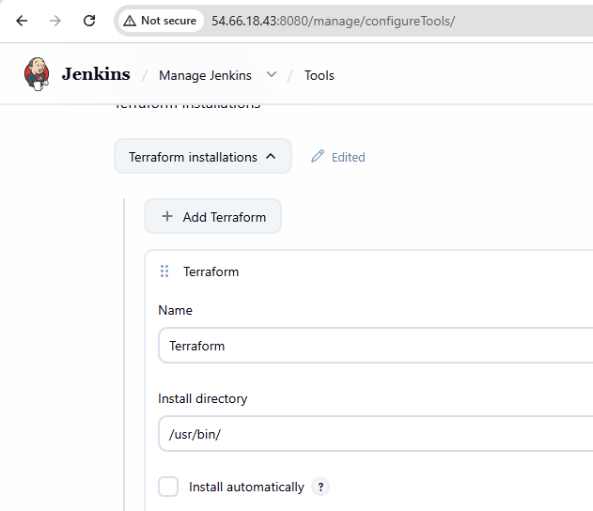
Lets create a main.tf file but here we already had the main.tf file which is the reason we copied the file from simple-tf to Terraform and executed with the same below:
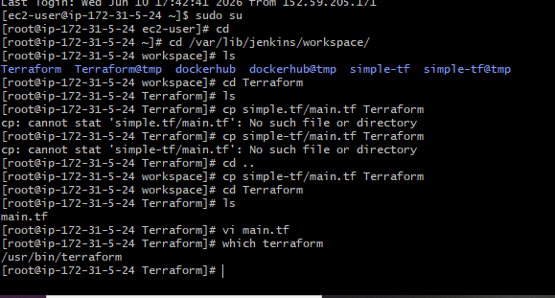
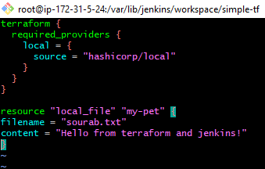
Now lets create a pipeline job
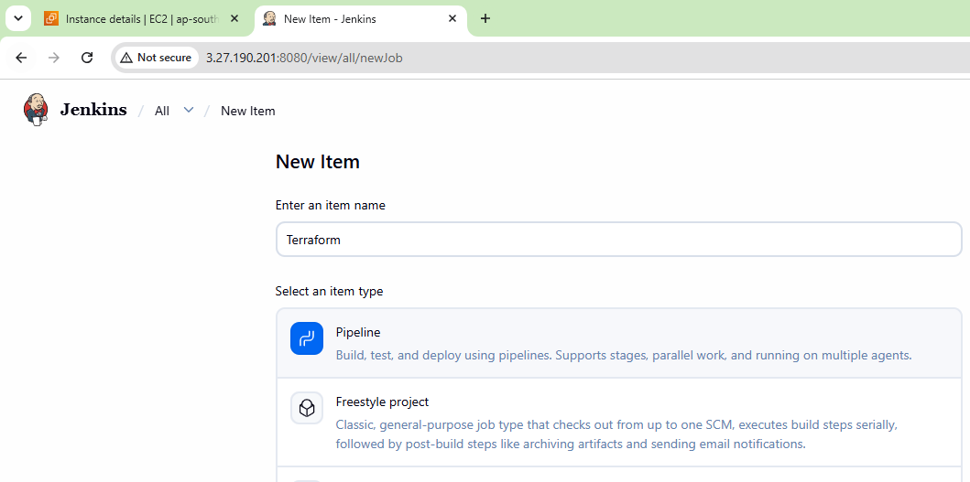
write a pipeline script
pipeline {
agent any
stages {
stage('Terraform Init') {
steps {
sh 'terraform init'
}
}
stage('Terraform Plan') {
steps {
sh 'terraform plan'
}
}
stage('Terraform Apply') {
steps {
sh 'terraform apply -auto-approve'
}
}
}
}
and successfully executed as well:
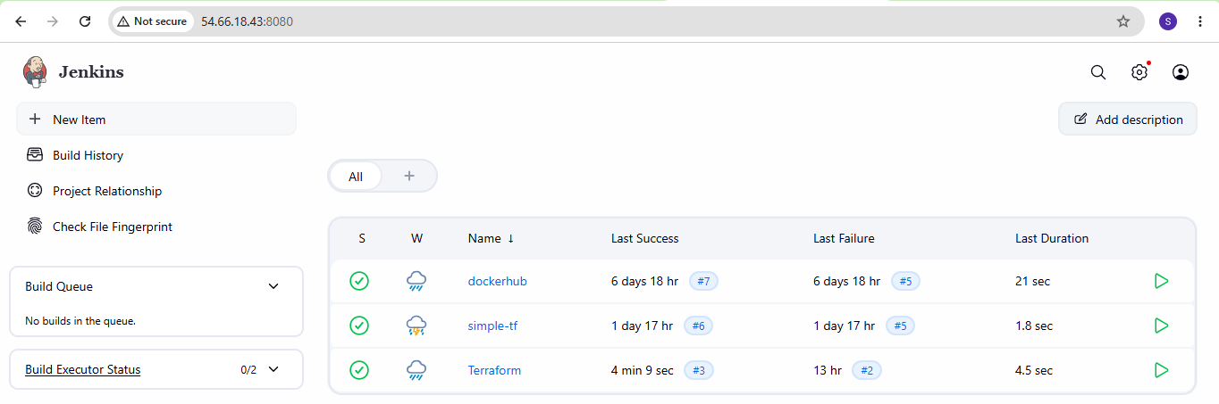
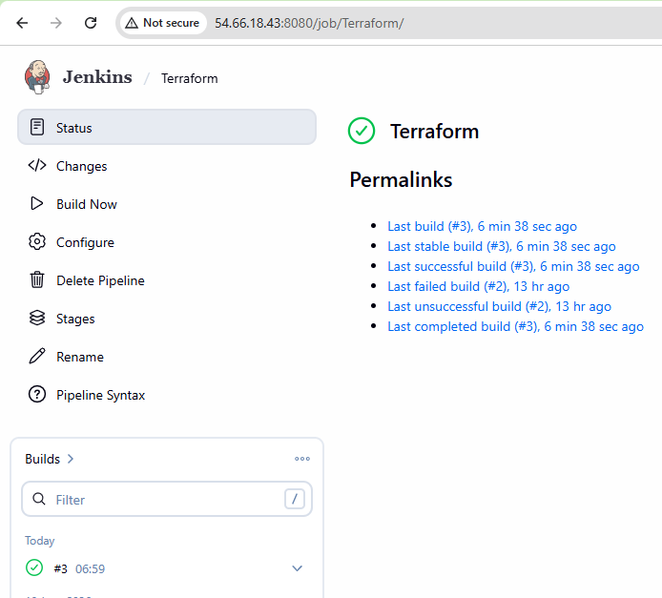
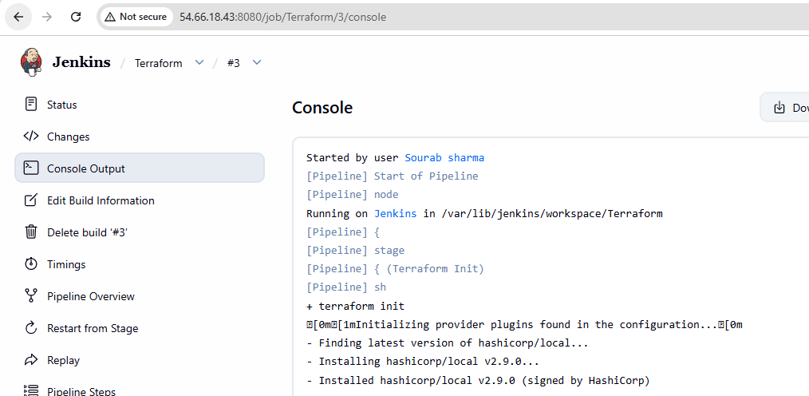
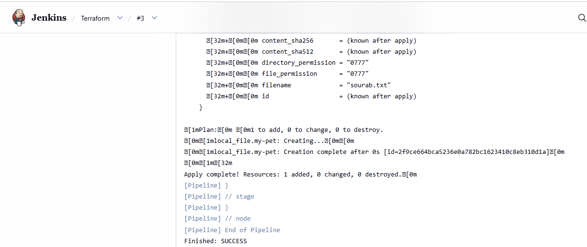
File created successfully:
